**Case Study - 6**

**Screen 1 - Login**

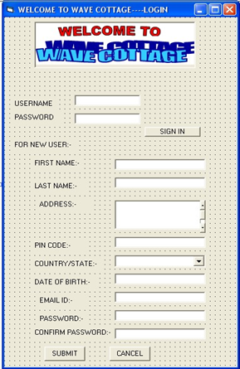

Number of inputs= 40

Number of outputs= 1

Number of inquiries= 0

Number of files= 0

Number of external interfaces= 2

**Screen 2 – Online Reservation**

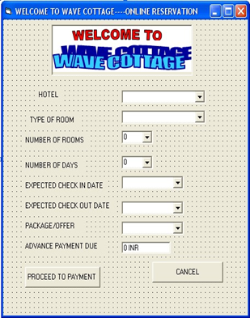

Number of inputs= 3+3+4+3+30+30+3= 76

Number of outputs= 2

Number of inquiries= 0

Number of files= 0

Number of external interfaces= 1

**Screen 3- Online Transaction**

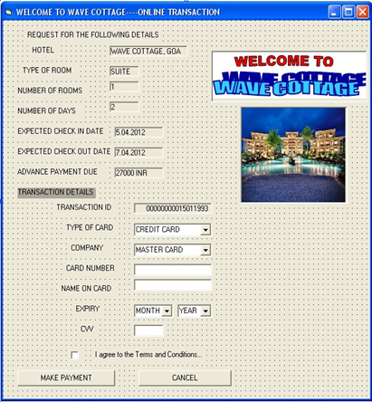

Number of inputs= 3+5+1+1+12+10+1+1= 34

Number of outputs= 8+1= 9

Number of inquiries= 0

Number of files= 0

Number of external interfaces= 1

**Screen 4 -Check in/Check out**

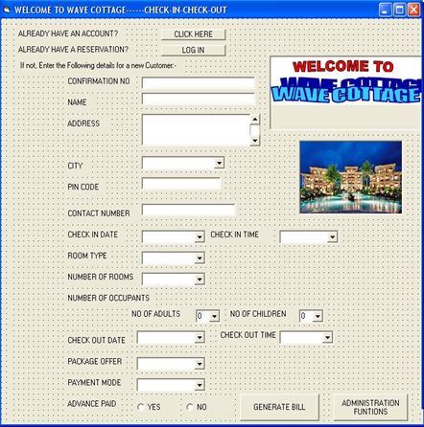

Number of inputs= 3+29+2+30+12+3+3+4+3+30+12+3+3+1= 138

Number of outputs= 1+1+1= 3

Number of inquiries= 1

Number of files= 0

Number of external interfaces= 1

**Screen 5- Embedded System**

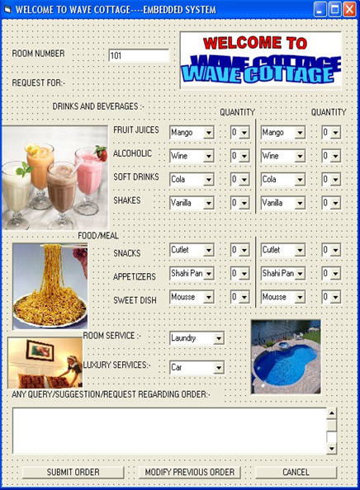

Number of inputs= 1

Number of outputs= 31+1= 32

Number of inquiries= 1

Number of files= 0

Number of external interfaces= 2

**Screen 6-Administrator functions**

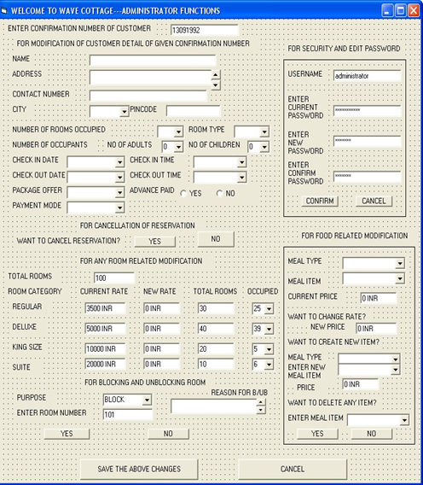

Number of inputs= 30+3+3+30+12+30+12+3+3+1+3+10+3+10=153

Number of outputs= 1+2+19+4+2+1+1+1+1+1= 33

Number of inquiries= 1+1= 2

Number of files= 0

Number of external interfaces= 1+1+1+1+1+1= 6

**Screen 7 – Bill generation**

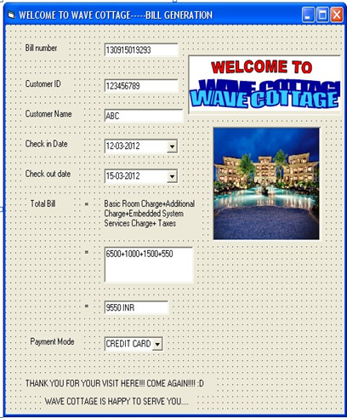

Number of inputs= 0

Number of outputs= 9

Number of inquiries= 0

Number of files= 0

Number of external interfaces= 0

**Calculate the following for the above screens:**

**1. Function points**

**For Screen 1:** FP = Total count × [0.65 + 0.01 × ∑Fi]

Total count = 40*3 + 1*4 + 2*5 = 134

∑Fi = 3+2+0+1+4+3+0+0+0+0+4+0+4+4 = 25

FP = 134 x [0.65 + 0.01*25] = 134*0.9 = 120.6

**For Screen 2:** FP = Total count × [0.65 + 0.01 × ∑Fi]

Total count = 76*3 + 2*4 + 1*5 = 241

∑Fi = 3+4+2+3+2+1+4+3+4 = 26

FP = 241 x [0.65 + 0.01*26] = 241*0.91 = 219.31

**For Screen 3:** FP = Total count × [0.65 + 0.01 × ∑Fi] Total count = 24*3 + 9*4 + 1*5 = 113 ∑Fi = 4+4+2+1+3+4+2+3+2+1+3+2+4 = 35 FP = 113 x [0.65 + 0.01*35] = 113*1 = 113

**For Screen 4:** FP = Total count × [0.65 + 0.01 × ∑Fi] Total count = 138*3 + 3*4 + 1*3 + 1*5 = 434

∑Fi = 4+3+2+1+3+3+1+3+1+3+1+3+4+3 = 35 FP = 434 x [0.65 + 0.01*35] = 434

**For Screen 5:** FP = Total count × [0.65 + 0.01 × ∑Fi]

Total count = 1*3 + 32*4 + 1*3 + 2*5 = 144

∑Fi = 3+4+1+3+2+2+3+3+4 = 25

FP = 144 x [0.65 + 0.01*25] = 144*0.9 = 129.6

**For Screen 6:** FP = Total count × [0.65 + 0.01 × ∑Fi] Total count = 153*3 + 33*4 + 2*3 + 5*5 = 622 ∑Fi = 4+4+2+3+2+3+2+3+2+3+3+2+2+3 = 38

FP = 622 x [0.65 + 0.01*38] = 622*1.03 = 640.66

**For Screen 7:** FP = Total count × [0.65 + 0.01 × ∑Fi]

Total count = 9*4 = 36

∑Fi = 3+4+2+3+4+3+2+2+3+3+2+4 = 35 FP = 36 x [0.65 + 0.01*35] = 36

**2. Object points**

**For Screen 1:** Object points = (weight*screens) + (weight*reports)

= 1*5 + 2*2 = 9

**For Screen 2:** Object points = (weight*screens) + (weight*reports)

= 1*3 + 2*1 = 5

**For Screen 3:** Object points = (weight*screens) + (weight*reports)

= 1*3 + 2*1 = 5

**For Screen 4:** Object points = (weight*screens) + (weight*reports)

= 1*6 + 2*4 = 14

**For Screen 5:** Object points = (weight*screens) + (weight*reports)

= 1*4 + 2*2 = 8

**For Screen 6:** Object points = (weight*screens) + (weight*reports)

= 1*7+2*4 = 15

**For Screen 7:** Object points = (weight*screens) + (weight*reports) = 1*0 + 2*1 = 2

**3. Effort**

NOP = (Object points) x [(100-reuse)/100]

PROD = 13

Effort = NOP/PROD = (Object points)/13

**For Screen 1:** Effort = 9/13 = 0.69 person-month

**For Screen 2:** Effort = 6/13 = 0.46 person-month

**For Screen 3:** Effort = 6/13 = 0.46 person-month

**For Screen 4:** Effort = 14/13 = 1.07 person-month

**For Screen 5:** Effort = 8/13 = 0.61 person-month

**For Screen 6:** Effort = 15/13 = 1.15 person-month

**For Screen 7:** Effort = 2/13 = 0.15 person-month